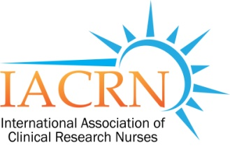
IACRN Nomination Application for 2017 Board of Directors

Name:

Degrees:

Preferred Address:

Preferred Phone Number:

Email Address:

Present Position (Employer and Title):

Education (include basic preparation through highest degree held):

Academic Institution | Major Area of Study | Degree/Qualification | Year Awarded

Please indicate below which position you are considering for nomination:

______ President Elect

______ Secretary

______ Member-at-Large

______ Global Member-at-Large

Briefly describe your professional experience, areas of expertise, and specific skills related to your abilities to serve on the Board of Directors of the International Association of Clinical Research Nurses.

Please attach the required documents (below) to this application form and email to: debbie@iacrn.org
by close of business on Friday, September 16, 2016
- Current CV or Biosketch
- 2 letters of recommendation / references (one to be from current employer)

Thank you very much for your support of IACRN.

