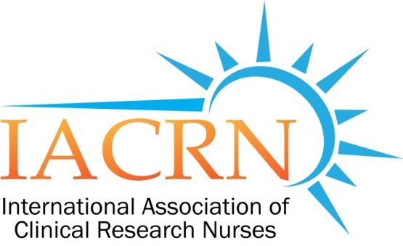

IACRN Research Committee Minutes
March 09, 2016

Members Present:
Cheryl Fisher - Chair | Kathy Grinke | Ann Marie Matlock
Catherine Griffith - Facilitator | Shaunagh Browning
Carolynn Thomas Jones | Rosemary Keller

Meeting convened at 3:37PM EST: Cheryl Fisher, Committee Chair presiding
- Announcements:
  - Welcome to new committee member Ann Marie Matlock, DNP, RN, NE-BC. Service Chief for Medical Surgical Specialties, NIH Clinical Center.
  - Committee goals for 2016 were submitted to IACRN Board. These goals delineate the Committee’s research agenda for the immediate future:
- Identify and characterize clinical research nursing workforce
  - Continue work of Castro & Bevans
- Extend and refine the description of the specialty practice of clinical research nursing
  - IACRN 2016 conference call for abstracts coming by end of March.
    - Goal is to submit one or both of the current projects.
  - Research Committee will have 2 meetings in October: Oct 12 and Oct 26 at Conference.

- Review of February 10, 2016: minutes approved as written. (K. Grinke motion; Shaunagh 2nd)
- Workgroup updates:
  - Workforce-Domains: Cheryl
    - Recap of meeting with Margaret Bevans, RN, PhD, AOCN®, FAAN. Dr. Bevans is the Program Director, Scientific Resources, Clinical Nurse Scientist, NIH. She is also co-author of “Validating the Clinical Research Nursing Domain of Practice
Purpose of meeting was to discuss the proposal and next steps.
  - Metrics: Carolynn working with Penny; will have report at next meeting.
  - Consultation pending with Gordon Hill for international perspective on survey questions.

Meeting adjourned at 4:40pm
Next meeting April 13, 2016

Submitted by
Catherine A. Griffith, RN,
Research Committee Facilitator

