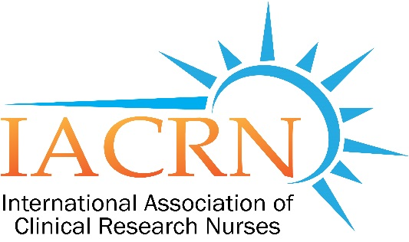
Boston Chapter of the International Association of Clinical Research Nurses

Boston Chapter of IACRN Meeting

Sexual Assault Simulation Course:
An Improvement in Knowledge, Skills, and/or Practices
for Professional Registered Nurses

Meredith Scannell, PhD(c), MPH, MSN, RN, SANE

Thursday, March 1,2018
5:30 PM to 7:00 PM

MGH Yawkey Conference Room 4-820

RSVP/questions: bostoniacrn@gmail.com

Open to all: Please pass along to any interested colleagues.

FOR ONLINE ATTENDANCE CREDIT
YOU MUST REGISTER BEFORE SESSION VIA LINK BELOW

https://attendee.gotowebinar.com/register/7911951922001605635

Find us on Facebook!

Twitter: @bostoniacrn

IACRN website

