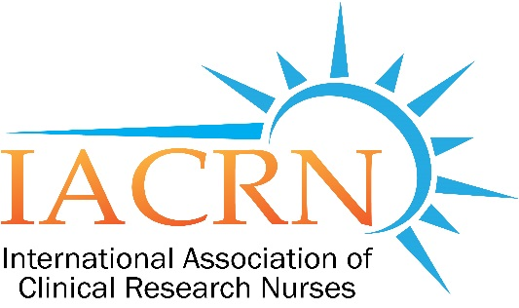
Boston Chapter of the International Association of Clinical Research Nurses

Boston Chapter of IACRN November Meeting

Shine on Boston Chapter: 2018 Boston Chapter posters presentations
from 10th Annual IACRN Conference

Thursday, November 1,2018
5:30 PM to 7:00 PM

At
Dana Farber Cancer Institute
Yawkey Building
Rooms# 1215/1216

Open to all~ Please pass along to any interested colleagues!!

FOR ONLINE ATTENDANCE CREDIT and CEU
YOU MUST REGISTER BEFORE SESSION VIA EMAIL: bostoniacrn@gmail.com

Join from PC, Mac, Linux, iOS or Android: https://zoom.us/j/815678995

Or iPhone one-tap :
US: +19294362866,,815678995# or +16699006833,,815678995#
Or Telephone:
Dial(for higher quality, dial a number based on your current location):
US: +1 929 436 2866 or +1 669 900 6833
Meeting ID: 815 678 995

International numbers available: https://zoom.us/u/ab5Gvu7Ffw

Find us on Facebook!

Twitter: @bostoniacrn

IACRN website

