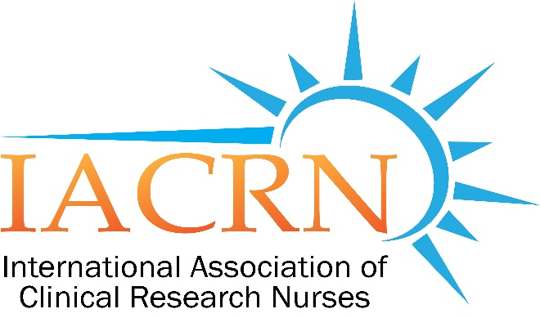
Boston - New England Chapter of the International Association of Clinical Research Nurses

November 7th 2019

Boston-New England Chapter of
IACRN Fall Meeting

Clinical Research Nurses Advancing Science
Through Scholarly Work

​
Thursday, November 7th

5:30 PM to 7:00 PM

Dana-Farber Cancer Institute
Yawkey Center Rm 1215/1216
450 Brookline Ave, Boston MA

RSVP via
NEW CHAPTER WEBPAGE:

https://bostoniacrn.wixsite.com/bostoniacrn

