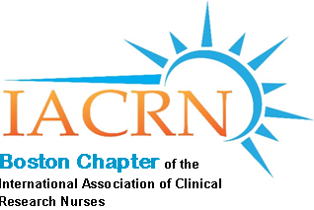

**Boston Chapter of IACRN Spring Meeting**

The Football Players Health Study at Harvard University:

A Novel Approach to Research

*Presenter*

Linda Pitler, RN, MS

Medical Navigation Nurse

​

**Thursday, March 7, 2019**

**5:30 PM to 7:00 PM**

**MGH Robbins Conference Room**

**Founders Building 2nd Floor, Room 244A**

*Criteria for earning contact hours (1.0 CEU) include attendance at the entire event*

*and submission of a completed evaluation form.*

Please RSVP and for CEU credit with ZOOM Link attendance send:

Full Name, Phone Number and Email address sent to

[bostoniacrn@gmail.com](mailto:bostoniacrn@gmail.com)

**Join Zoom Meeting \***

<https://zoom.us/j/462564319>

One tap mobile

+19294362866,,462564319# US

+16699006833,,462564319# US (San Jose)

Dial by your location

+1 929 436 2866 US

+1 669 900 6833 US (San Jose)

+1 647 558 0588 Canada

Meeting ID: 462 564 319

Find your local number: <https://zoom.us/u/abhExYxUJj>